**Visulaisations Of Diamond Dataset Model**

**#Correlation Matrix:**

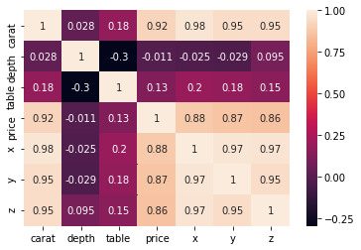

From the above correlation matrix it can be seen that price and carat are highly correlated to each other and carat is also highly correlated to x (Length), y (Width) and z (Depth). But, it can also be observed that, table and depth are weakly correlated to each other.

**#Carat Analysis:**

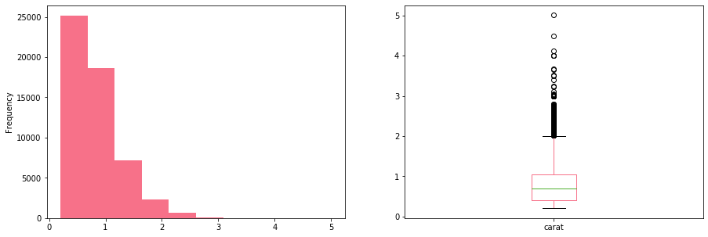

It can be observed that, frequency is highest between 0 and 1 but a significant drop can be noticed after that. Boxplot gives a better view of the outliers.

**#Clarity Analysis:**

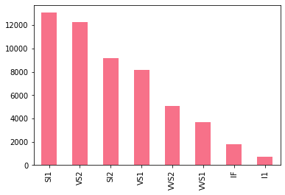

From above chart it can be interpreted that, more than 12,000 diamonds falls under SI1 type, followed by VS2 which is approximately at 12,000. SI2 and VS1 are trailing VS2 at 9,000(approx.) and 8,000(approx.) respectively. VVS2 and VVS1 are under 5,000 whereas, IF (considered to be the best type) is at 2,000(approx.) while I1 (considered to be the worst type) is almost 1,000.

**#Cut Analysis:**

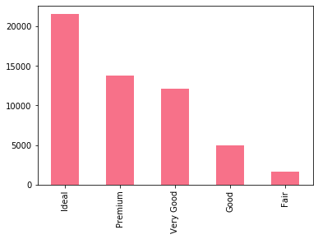

From the above chart it can be inferred that, cut quality of more than 20,000 diamonds are ideal whereas, 14,000(approx.) comes under premium quality. Cut quality of ‘Very Good’ diamonds is somewhere between 12,000 and 13,000. 5,000 diamonds falls under ‘Good’ quality, while almost 2,000 are fairly cut.

**#Depth Analysis:**

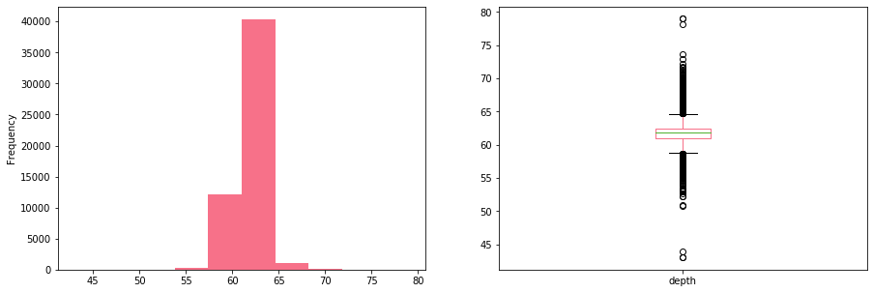

Depth percentage is calculated by dividing z (Depth) by mean of x (Length) and y (Width). It can be seen that 40,000 diamonds have depth between 60% and 65%, whereas, with the help of boxplot it can be observed that few diamonds have depth of 80% and less than 45%.

**#Table Analysis:**

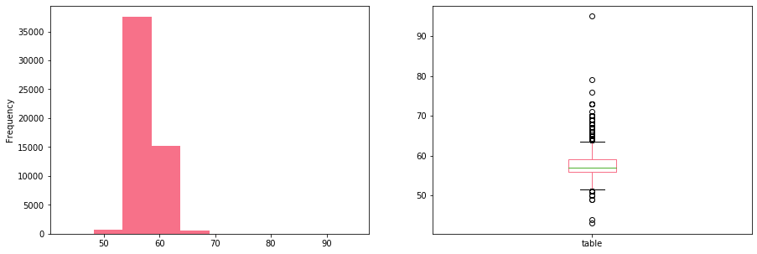

Table depicts the width of top of diamond relative to widest point. From the bar chart it is observed that, frequency is highest between 55 and 60 whereas, only one diamond is above 90.

**#X Analysis:**

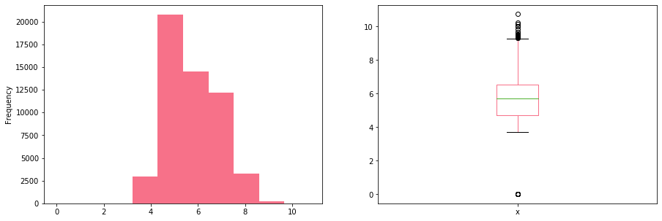

It can be depicted that 20,000 diamonds have the length of 5mm, while around 14,000 diamonds have the length of 6mm. 12,000(approx.) have 7mm length whereas, 2,500 diamonds have length of 4mm and 8mm(each). Only few diamonds have length more than 8mm.

**#Y Analysis:**

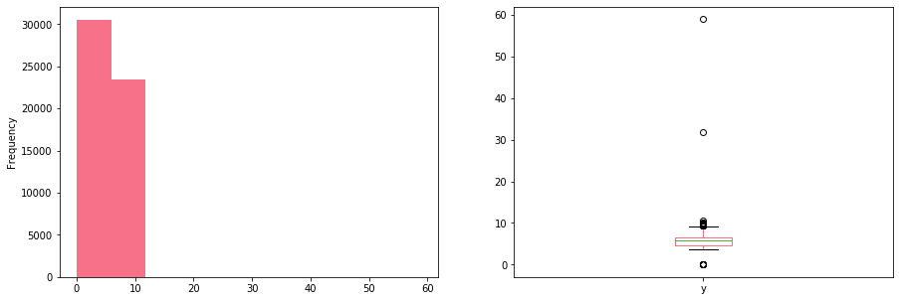

It can noticed that 30,000 diamonds have the width between 1 and 6 mm(approx.), whereas, 23,000 diamonds(approx.) have the width between 7 and 11 mm. From the boxplot it is also observed that only 1 diamond has the width more than 30 mm and another diamond with the width of 60 mm while only 1 diamond has the width close to 0 mm.

**#Z Analysis:**

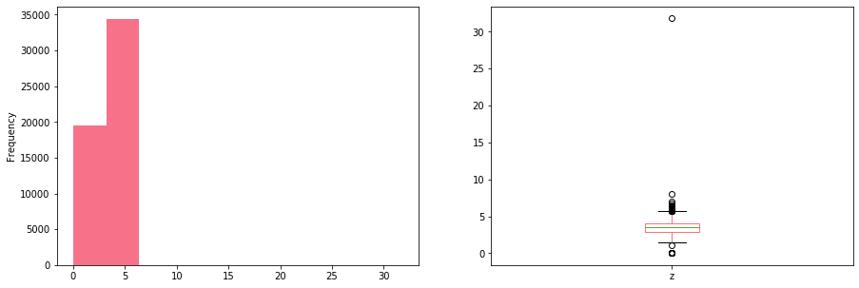

From the above charts it can be concluded that, around 34,000 diamonds have the depth between 4mm and 6 mm, while less than 20,000 diamonds have depth between 1 mm and 3 mm. Only 1 diamond has the width more than 30 mm.

**#Price Analysis:**

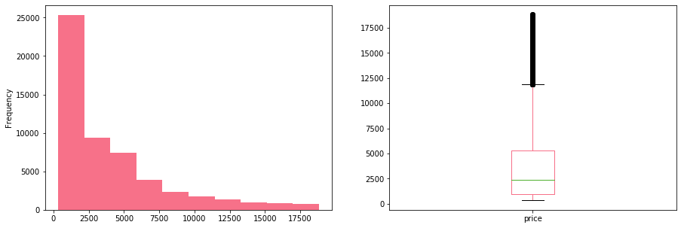

From the above charts it can said that, 25,000 diamonds have a price range between $200 and $2000, while less than 10,000 diamonds comes under the range of above $2,000 up to $4,500. Around 7,000 diamonds have a range between $4,600 and $5,200. As the price range increases, number of diamonds decreases. Less than 1,000 diamonds falls under the range of $12,500 to $17,500.

Below charts displays the impact of other attributes (such as, carat, depth, and more) on price. It can be seen how price varies depending on different attributes.

